

SPONSORSHIP PROSPECTUS
Winnipeg Crypto, Blockchain and Alternative Currency Conference
October 11-13, 2019 - Winnipeg, Canada

Thank you for your interest in the Winnipeg Crypto, Blockchain and Alternative Currency Conference,

The financial and technology industries are moving and changing fast these days. With new advances in digital, financial transactions and accountability and the growing distribution of many things, everyone is being affected. Ensuring businesses and individuals are educated on the newest innovations in technology is a significant part of our focus for our annual Winnipeg Crypto, Blockchain and Alternative Currency Conference conference and expo.

We are excited to announce our inaugural event this coming fall 2019 which will be held in Winnipeg, Canada from October 11th – 13th, with many top tier speakers discussing the past, present and future of digital and alternative currencies and related technologies that we expect will be valuable to attendees. The accompanying expo will provide opportunities for the conference attendees, as well as the general public, to get access to how these technologies are working in the real world.

We expect the 2019 event will be a fantastic opportunity for those who attend and participate in the event, which is geared to service central North America, while inviting the world to our innovation playground.

We anticipate over 100 attendees, 20+ national and international speakers, and a trade exhibition of over 20 booths. This is an invaluable opportunity to build awareness for your brand among an audience of finance and business professionals from around Winnipeg, North America, and the world.

We believe the conference will deliver terrific ROI for sponsors who will gain exclusive access to often un-accessible industries as well as highly niche markets which are difficult to gain audience to, during the sessions and exhibition.

We offer a simple range of opportunities for base sponsorship as well as many a-la-cart opportunities to suit your needs, as outlined in the prospectus. Highly sought after positions will sell out so we encourage you to get in quick.

Don’t fit in a box? We’re always excited to work with our sponsors to come up with tailored solutions to connect you with our audience. From break-out sessions, special products or anything else you think would be suitable. Contact us to discuss your needs!

On behalf of the entire Winnipeg Crypto, Blockchain and Alternative Currency Conference team, I hope you’ll choose to partner with us for what’s shaping up to be a very exciting conference!

Sincerely
John Thore Stub Sneisen
Lead Host, Winnipeg Crypto, Blockchain and Alternative Currency Conference

About The Autonomous Group
- - - -
The Autonomous Group is a think tank and innovation community that strives to keep members and the public aware of the changing world of the financial industry in collaboration with technology advancements within a global playground.

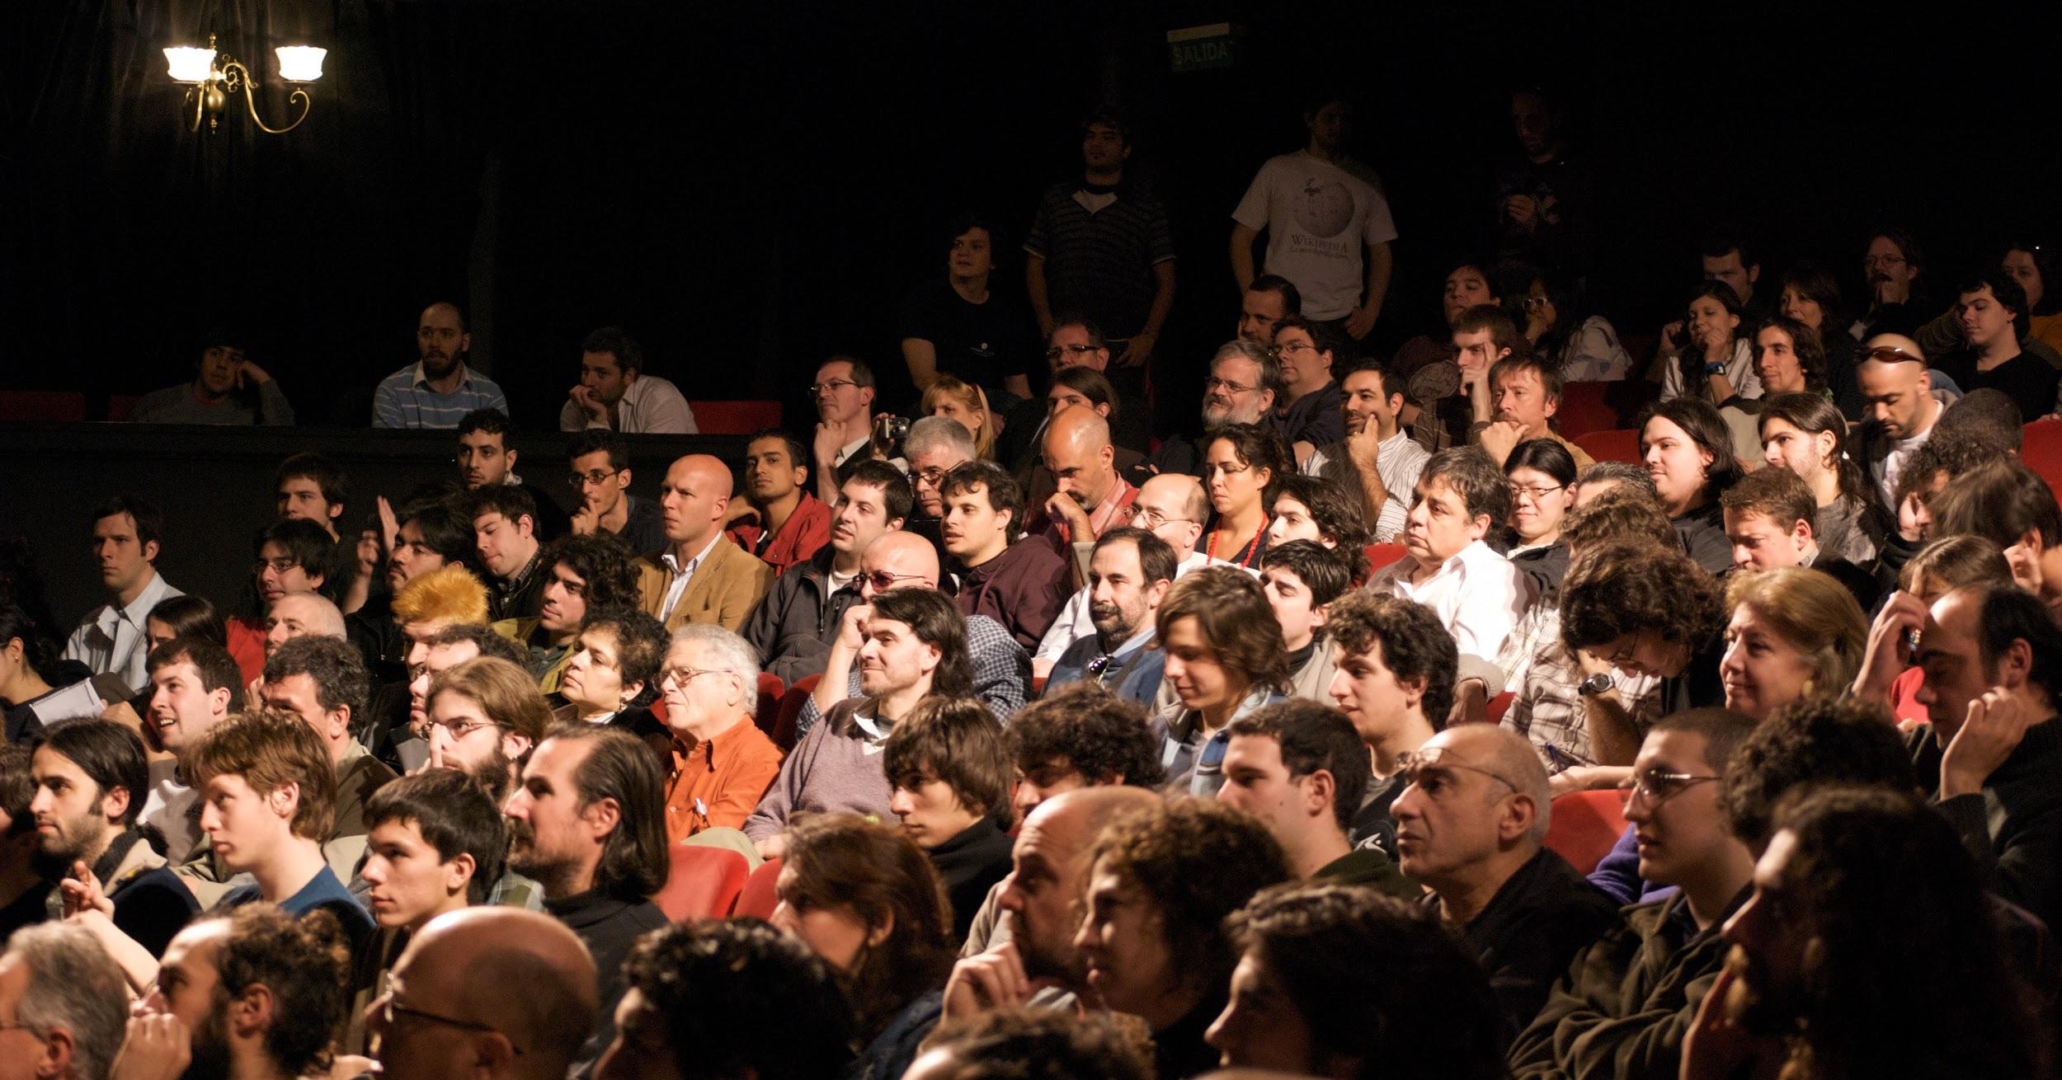

About the Winnipeg Crypto Conference and Expo
- - - -
The Winnipeg Crypto Conference and Expo is an annual conference for leaders in related industry revolving around finance and technology frameworks. The theme for 2019 is: The Road Ahead; Purposeful investigation and adoption.
This conference is a fantastic opportunity to gather information and learn more about the industries and how these changing environments can be met head on; there is an extensive list of high quality speakers, seminars and workshops, coupled with a fantastic trade exhibition assembled to showcase the industries.

Fast Facts
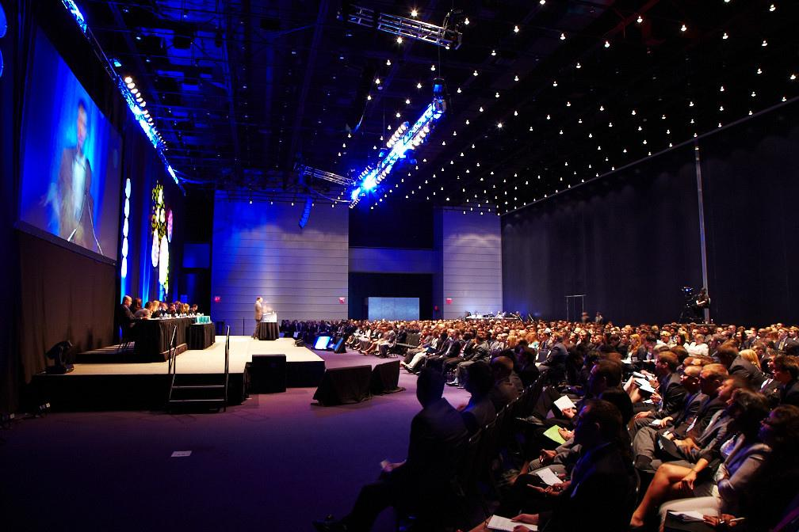
- - - - -
- October 11-13 2019
- Winnipeg, Manitoba
- 1000+ guests
- 20+ speakers
- BOF/Fireside chats
- attendee workshops
- Saturday night Gala Dinner
- Friday social mixer
- 20+ booth expo
- winnipegcryptoconference.com

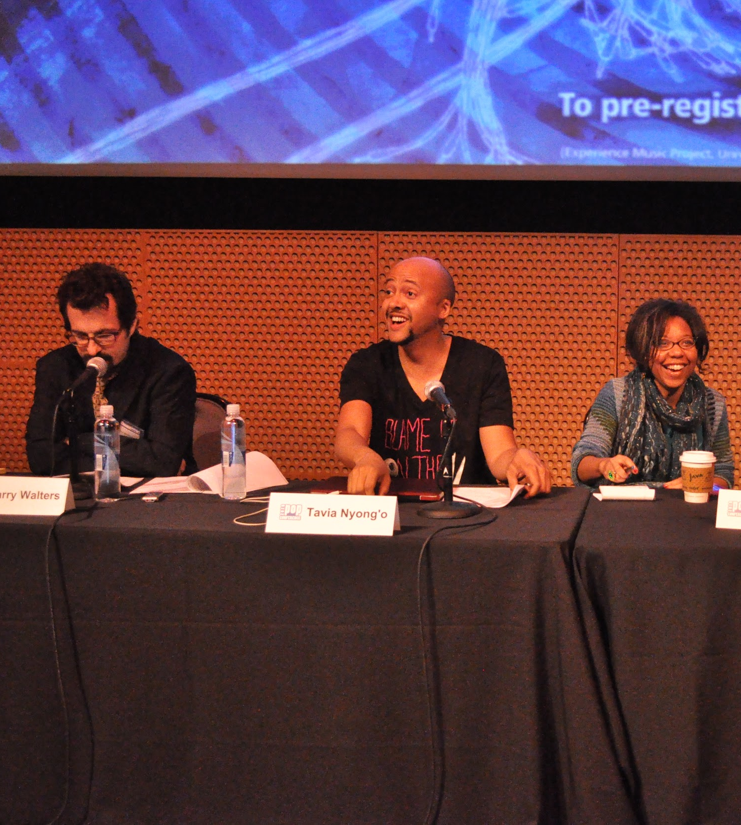

Speaker Profile
- - - - -

David Morgan

A precious metals aficionado with degrees in finance and engineering, he originated The Morgan Report, a monthly report that covers economic news, the global economy, and to make substantial capital gains by investing in the Resource Sector. The Model Portfolio covers top-tier, mid-tier, speculative and special situations.
David considers himself a big-picture macroeconomist whose main job is education—educating people about honest money and the benefits of a sound financial system.
His ideas can be seen in the movie Four Horsemen, a Feature Documentary. Watch the full length video below.
A dynamic, much-in-demand speaker all over the globe, he has appeared on CNBC, Fox Business, and BNN in Canada. He has interviewed- The Wall Street Journal, Futures Magazine, Investing Rules and numerous other publications.
As publisher of The Morgan Report, he has appeared on CNBC, Fox Business, and BNN in Canada. He has been interviewed by The Wall Street Journal, Futures Magazine, The Gold Report and numerous other publications.
themorganreport.com

Anthem Hayek Blanchard

Anthem is the CEO of Hercules SEZC is a software company who has created a supply chain management platform that utilizes the strength of the blockchain to eliminate racketeering and collusion in the supply chain management industry.
He is also the CEO of AnthemGold Launching innovative precious metal-backed crypto currency that easily and securely allows people to acquire, store and spend gold. herc.one

Andy Hoffman

For 15 years, Andy Hoffman has been one of the most prolific content providers in the alternative financial media, in both the written and podcast formats. Equally relevant is his passion for fostering the global adoption of sound money – at the expense of the fiat currency that has wrought unfathomable political, economic, and social destruction.
During a three-decade career in financial markets; as a trader, analyst, and commentator – and since 1998, a Chartered Financial Analyst (CFA); Andy has professionally marketed public oilfield service and mining companies, Precious Metals, and crypto currency.
At CryptoGoldCentral.com, he consults with individuals regarding all crypto currency-related issues, and altcoin developers on how to market existing or yet-to-be-launched crypto currencies.
As a leader of the Bitcoin community and World Crypto Network personality; with strong followings on Twitter and Steemit; and unparalleled professional marketing experience of financial assets; Andy can help existing and yet-to-be-launched crypto currencies to improve their market penetration and acceptance. cryptogoldcentral.com

Rodrigo Ambrissi

Documentary Director “Venezuela and the Crypto currency Revolution” He is a Tech Savvy Crypto currency & Blockchain Enthusiast and YouTuber. Professional Speaker and MC at Conferences. He also is a Freelance Crypto News Reporter.
Rodrigo is also the CEO of EletroPay a groundbreaking Point of Sale System to process crypto currency payments in a very affordable way. youtube.com

Daniel Keyes

Daniel Keyes is co-founder and COO of EOS Nation, a top block producer on the EOS mainnet.
Aside from business strategy and operations, Daniel focuses much of his time on product development and community engagement. Most notably, he partnered with members of competing block producers and managed the development of the EOS referendum system and the automated genesis lost key recovery system.
Prior to founding the first EOS community in Toronto, Daniel spent about a decade in the financial technology industry working several diverse roles. His extensive experience in customer service, sales, sales coaching, agent training, digital marketing, digital process management, and product management eventually lead him to consulting for a blockchain dev shop.
Daniel earned a Bachelor of Journalism from Ryerson University in 2009 and worked as a chase producer intern at Global TV.
Daniel lives by the principles of Truth, Love, and Freedom.
eosnation.io

Vít Jedlička

Vít Jedlička received his bachelor’s degree from the University of Economics, Prague, the Czech Republic in 2009 with a thesis on central banking and monetary policy. At the same time, he became a founding member of the Czech Libertarian Free Citizens Party. He also started libertarian educational NGO Reformy.cz - whose video channels have well more than over 18 million views. He received his Master’s degree in political science from CEVRO Institute in 2014, where his final thesis concentrated on Building Global Government.
He founded the Free Republic of Liberland on April 13th, 2015 and was elected its first President. Liberland has over half a million people who have registered and applied for citizenship. He has been a speaker on many high-level conferences such as the Horasis Global Meeting. He has been interviewed countless times by the mainstream media and has appeared on dozens of TV interviews including Bloomberg. liberland.org

John Thore Stub Sneisen

John is the founder of Winnipeg Crypto Conference. John is a 2 Times Bestselling Author and has been featured in Magazines, Radio and TV like CBC, CTV, BBC and City TV speaking on topics like Economics and Crypto currency. John has also helped host a truth based conference with Freedom Force International that he is a Leadership Council member of. John works with Josh Sigurdson of World Alternative Media doing video reports on economics and money WAM is one of the worlds fastest growing Alternative Media Platforms. John is an Economic Adviser to UOS Blockchain. John is the CEO of The Economic Truth where he educates 1000's on people about money and economics. John also has a background in Telecom and Networking Infrastructure. theeconomictruth.org

Stefan Aarnio

Stefan Aarnio is a Serial Entrepreneur, Real Estate Investor, Author, Real Estate Coach. Stefan Aarnio is an award winning real estate Investor, Entrepreneur, Author and winner of the 2014 Rich Dad International Hall of Fame award. He has been featured in Canadian Real Estate Wealth Magazine and Entrepreneur Magazine named him one of the Top 10 Real Estate Influencers to Follow.Starting with only $1200, Stefan has built a multi-million dollar portfolio for himself and his partners and been recognized on The Self Made List. He is coming out with his new book in April Hard Times Create Strong Men: Why the World Craves Leadership and How You Can Step Up to Fill the Need, the history of Empires. stefanaarnio.com

Martin Lalonde
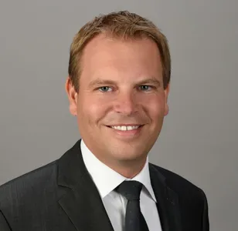
Martin is the president of Rivemont Investments, the firm in charge of the investment decisions of the Rivemont Crypto Fund, the only actively managed crypto currency fund in Canada. Before founding Rivemont Investments, he was a senior investment, mergers and acquisitions analyst for a major Canadian organization. Mr. Lalonde holds a Master’s Degree in Business Administration (MBA) from the University of Ottawa with specialization in international trade from the École supérieure de commerce of Reims, in France. He also holds the title of Chartered Financial Analyst (CFA). rivemont.ca

Kingsley Edwards

Kingsley Edwards founded Leet, an online esports bitcoin platform, in 2013 with the vision of integrating cryptocurrencies with popular video games. After Leet was acquired by Unikrn, he acted as a Director for the UnikoinGold token sale that sold over $30M in tokens. Kingsley is now focused on bringing his experience and network from the crypto community to help other organizations achieve success in the blockchain industry with Block 16. He is also the CEO of Flote Fighting for free speech and against monetary censorship of alternative media voices. linkedin.com

Luis Fernando Borges Mises
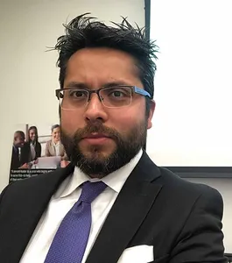
Luis Fernando Mises is a Consultant that teaches Leadership all over the United States, a Yoga instructor, a Meditation teacher, a student of Austrian Economics, a Statesman with the Libertarian Party, a Curandero, an Entrepreneur, and a Family man. He realized his personal mission was to empower others and to be present; and this realization propelled him to create Emancipated Human as a way to bring stories that would help people see the nature of the police state we currently live in, ideas to hack the world, interviews with people that have practical examples, and inspiration to live a freer life. emancipatedhuman.com

Dan Dicks

Dan is an investigative journalist and award winning documentary film maker. He is also the founder of an independent media outlet known as Press For Truth which produces videos and films that directly challenges the mainstream media's narratives of events that shape our world. Dan frequently travels the world covering stories and events that the mainstream media is not willing to touch or puts their heavily biased spin on. He is also a musician and wrote and performed the music for all five of his films. As founder and owner of Press For Truth Dan continues to create thought provoking videos and documentary films for his website pressfortruth.ca

Rita Tully

Rita has run her accounting business for over 30 years and has always been at the forefront of implementing technology to benefit her customers and to make her office run highly efficiently. She educates her customers on how Crypto and Blockchain can be highly beneficial for businesses to adopt. Rita is one of the few tech-savvy accountants that is an early adopter of any new technology to help her clients to the fullest potential on mitigating their tax hits. Having a background in computer technology she was in the first group of accountants to use technology in their practice.

Attendee Profile
- - - - -
The WCC (Winnipeg Crypto Conference) 2019 anticipates over 1000 session attendees and another 1000 expo hall walk through traffic, from the finance, technology, retail, education, and government sectors due to the broad nature of Crypto Currencies and Blockchain. Job titles include C level executives, computer technologists, sales representatives, money managers, data scientists and researchers.

Job Title
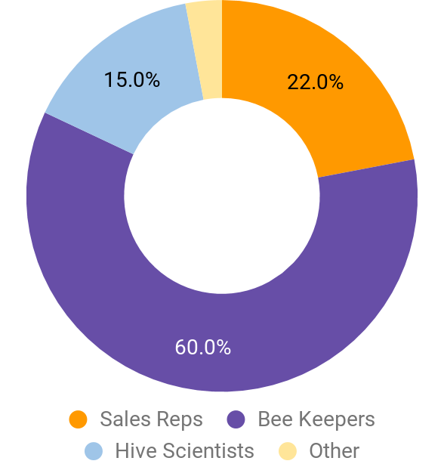

Age

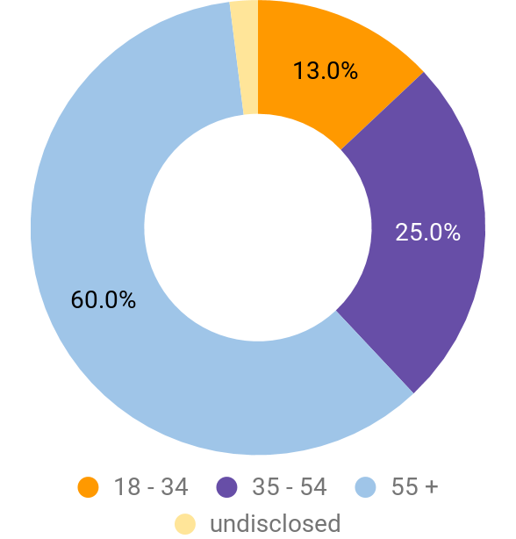

Sponsorship Opportunities
- - - - -

Category / Item | Quantity | Investment | Page
Platinum Partner | 4 | $10,000 | 14
Gold Partner | 10 | $7,500 | 15
Silver Partner | 20 | $5,000 | 16
Event App | 1 | $10,000 | 11
Registration Area | 1 | $8,000 | 12
Interactive Session | 1 | $4,000 | 12
Badge and Lanyard | 1 | $4,000
Welcome Reception | 1 | $1,000
Coffee Cart | 1 | $1,000
Networking Drinks | 1 | $1,000
In-App Opportunities |  | various
Exhibition Stand |  | various

Platinum Partner (4 Available) $10,000
- - - - - - - - - -
Before the Conference
- Platinum Partner acknowledgement and logo on the Event website
- Partner logo on all event marketing
- Organization name, logo and 300-word company profile on the Event website and Event App
- Provided with the “Proud sponsor of Winnipeg Crypto Conference 2019” logo for use on marketing material

During the Conference
- 2 Banquet Dinner tickets
- Five minute speaking opportunity at the Conference
- 4 Conference tickets
- 6 Exhibition Tickets
- Organization name, logo and 300 word company profile in the Event App
- Venue banners, including hallway, session hall, and exhibition hall
- Two A4 promotional inserts in delegate satchels (inserts provided by sponsor)
- Sponsor logo on presentation slides at conference where available
- 20x10 exhibition hall booth included
- Prominent digital ad placement at venue and on event app
After the ConferenceAfter the Conference
- Sponsor acknowledgement in the post event report.
- Photos of the event will be displayed on the 2019 event website
- Organization details on the event website
- Handbook available as an e-book on the event website
- First right of refusal for the Platinum sponsorship at 2019

Gold Partner (10 Available) $7,500
- - - - - - - - - -
Before the Conference
- Gold Partner acknowledgement and logo on the event website
- Partner logo on all event marketing
- Organization name, logo and 300-word company profile on the event website and Event App
- Provided with the “Proud sponsor of Winnipeg Crypto Conference 2019” logo for use on marketing material

During the Conference
- 2 Banquet Dinner tickets
- Five minute speaking opportunity at the Conference
- 2 Conference tickets
- 8 Exhibition Tickets
- Organization name, logo and 300 word company profile in the Event App
- Venue banners, including hallway and exhibition hall
- Two A4 promotional inserts in delegate satchels (inserts provided by sponsor)
- Sponsor logo on presentation slides at conference where available
- 50% discount on Exhibitor Booths
- Prominent digital ad placement at venue and on event app

After the Conference
- Sponsor acknowledgement in the post event report.
- Photos of the event will be displayed on the 2019 event website
- Organization details on the event website
- Handbook available as an e-book on the event website
- First right of refusal for the Platinum sponsorship at 2019

Silver Partner (20 Available) $5,000
- - - - - - - - - -
Before the Conference
- Silver Sponsor acknowledgement and logo on the event website
- Partner logo on all event marketing
- Organization name, logo and 300-word company profile on the event website and Event App
- Provided with the “Proud sponsor of Winnipeg Crypto Conference 2019” logo for use on marketing material

During the Conference
- Five minute speaking opportunity at the Conference
- 2 Conference tickets
- 4 Exhibitor Tickets
- Organization name, logo and 300 word company profile in the Event App
- Venue banners, including hallway
- One A4 promotional inserts in delegate satchels (inserts provided by sponsor)
- Sponsor logo on presentation slides at conference where available
- 50% discount on Exhibitor Booths
- Prominent digital ad placement at venue and on event app
After the Conference
- Sponsor acknowledgement in the post event report.
- Photos of the event will be displayed on the 2019 event website
- Organization details on the event website
- Handbook available as an e-book on the event website
- First right of refusal for the Platinum sponsorship at 2019

Event App Partner (1 Available) $10,000
- - - - - - - - - -
Before the Conference
- Acknowledgement as App Partner for WCC 2019
- App Partner acknowledgement and logo inclusion on the WCC website
- Partner logo on all event marketing
- Organization name, logo and 300-word company profile on the WCC website and Event App
- Provided with the “Proud sponsor of WCC 2019” logo for use on marketing material
During the Conference
- Joint naming rights to the Event App
- Branding on App Icon, Splash Screen and Main Menu
- Sponsor Banner on Main Menu, linked to an app page, contact form or external website.
- Dedicated menu icon linked to home page or info page
- Half page advertisement in Handbook
- Organization name, logo and 300 word company profile in the WCC Handbook
- Organization name, logo and 300 word company profile in the WCC Event App
- Opportunity to be a session panelist
- One A4 promotional insert in delegate satchels (provided by sponsor)
- Sponsor logo on presentation slides at conference where available


After the Conference
- App Partner acknowledgement in the WCC 2019 post event report.
- Photos of the event will be displayed on the WCC website until the end of 2019
- Organization details on the WCC website until the end of 2019
- Handbook available as an e-book on the WCC website
- First right of refusal for the Event App Partnership at WCC 2021
- The App will be accessible to delegates for three months after the conference

Registration Partner (1 Available) $8,000
- - - - -
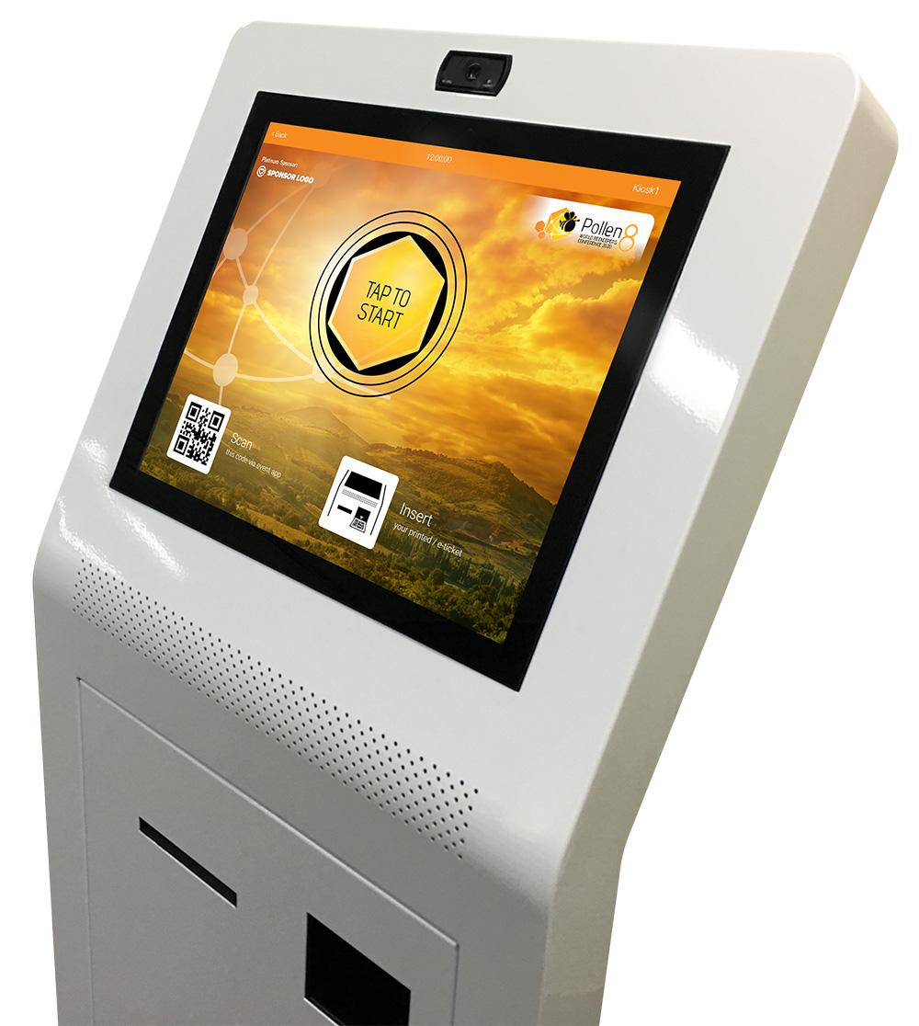
Benefits
- Four pull up banners within the registration area (supplied by sponsor)
- Sponsor branding on Kiosk Screens
- Registration Partner acknowledgement and logo inclusion on the WCC website
- Partner logo on all event marketing
- Organization name, logo and 300-word company profile on the WCC website and Event App
- Provided with the “Proud sponsor of WCC 2019” logo for use on marketing material

Interactive Session Sponsor (1 Available) $8,000
- - - - -
- Acknowledgement as Interactive Session Sponsor for WCC 2019 prior to each live polling or Q&A session
- Sponsor logo included on Interactive Session display screens
- Custom message shown prior to and after session (subject to approval)
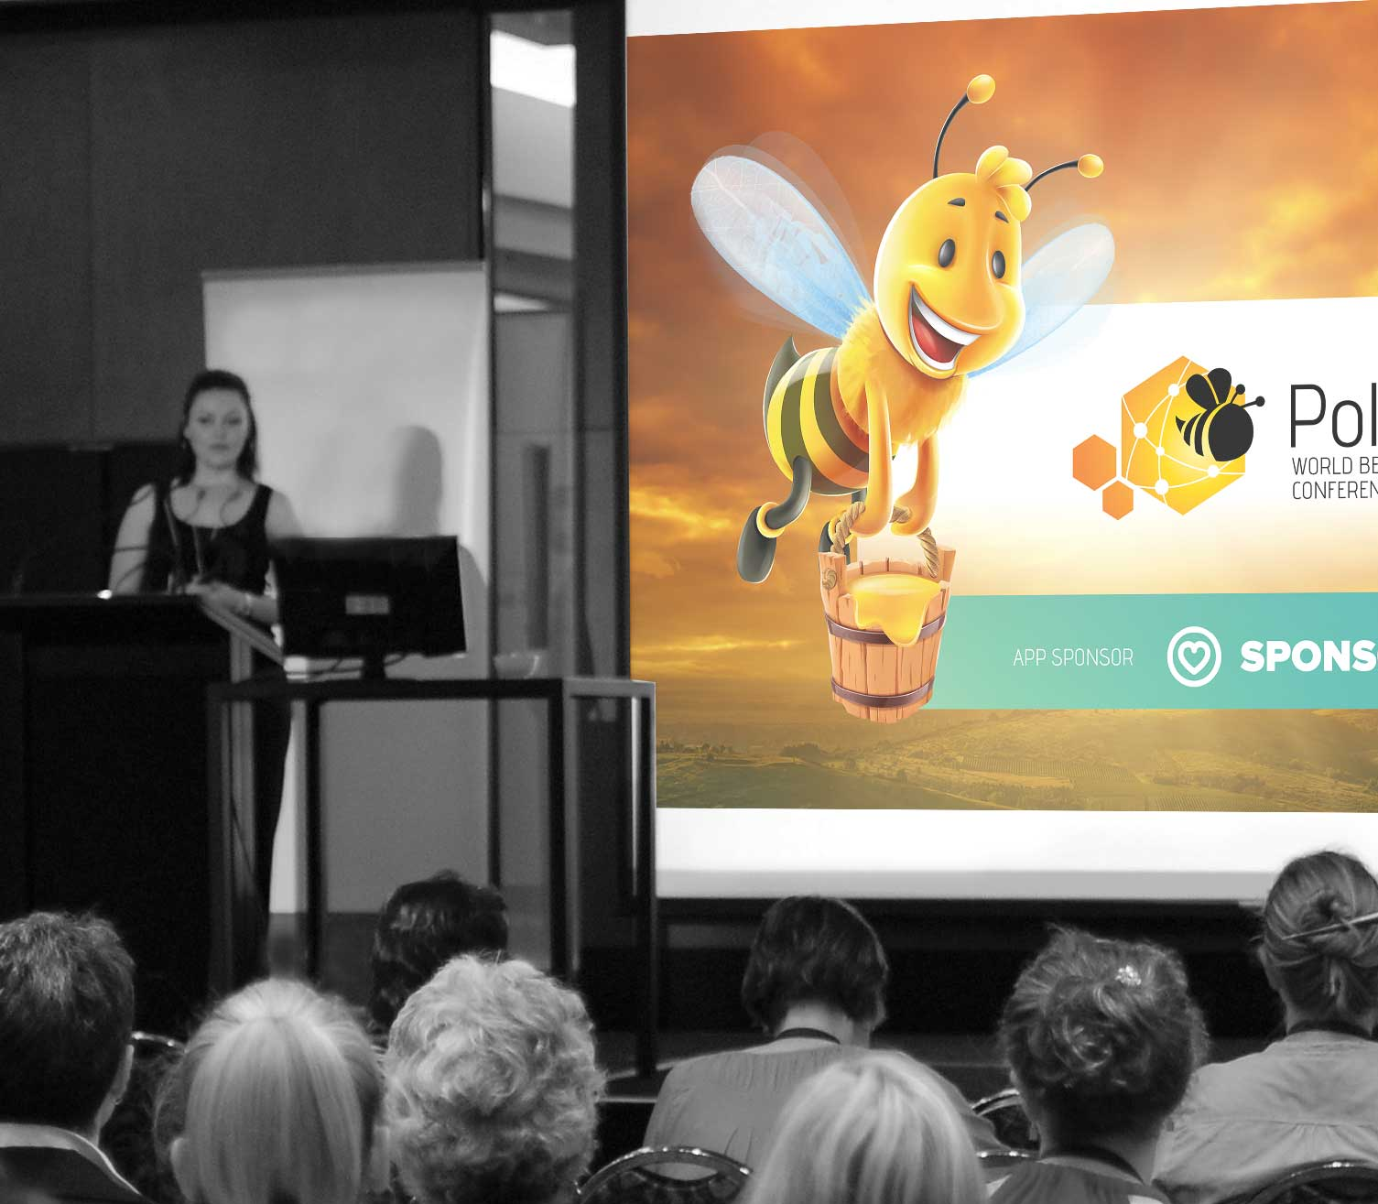
- Sponsor banner on relevant session pages within the Event App, linked to sponsor page, contact form or website.
- Partner logo on all event marketing
- Organization name, logo and 300-word company profile on the WCC website and App
- Provided with the “Proud sponsor of WCC 2019” logo for marketing purposes

Exhibition Inclusions
- - - - -
Booth types and rates
20’x20’ large booth: $1,300
20’x10’ medium booth: $900
10’x10’ regular booth: $600

Inclusions
Furniture - table and 2 chairs
Extra
Power
All additional requirements can be hired through our trusted provider HiveHire
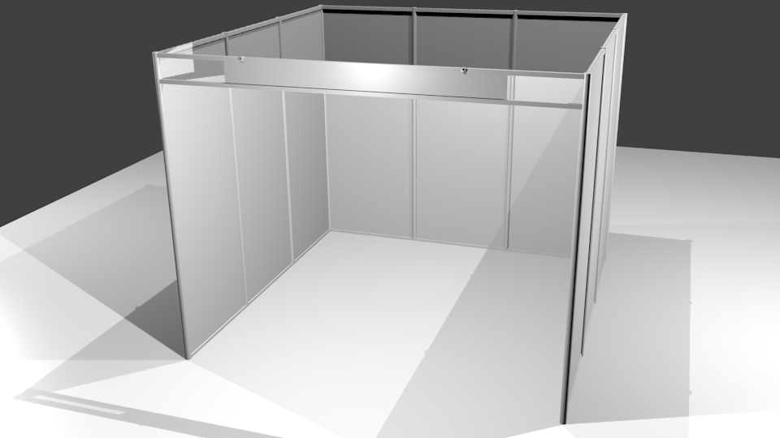
Thanks to our past Sponsors
- - - - -

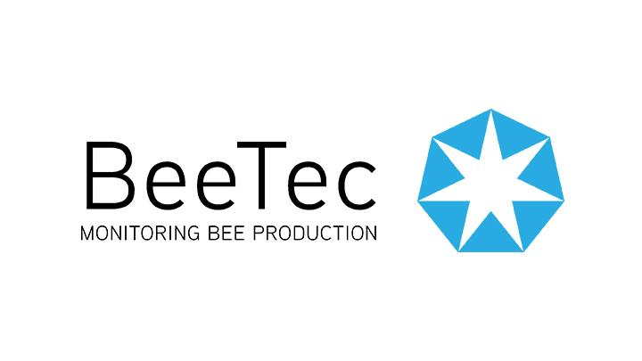



TERMS & CONDITIONS
- - - - -
Lorem ipsum dolor sit amet, consectetur adipiscing elit. Integer eu massa in leo condimentum convallis. Aenean ac pretium nibh, quis suscipit enim. Etiam id enim diam. In hac habitasse platea dictumst. Praesent sollicitudin porttitor turpis. Nullam hendrerit vestibulum aliquet. Vivamus ac sem id felis tempor tincidunt. Donec rutrum aliquet dolor in suscipit. Ut iaculis, lacus non semper hendrerit, dolor mauris pharetra sem, vel finibus neque purus molestie turpis. Maecenas vestibulum velit id feugiat vulputate. Curabitur blandit sed enim fermentum tincidunt. Orci varius natoque penatibus et magnis dis parturient montes, nascetur ridiculus mus. Vivamus feugiat, augue a fermentum vulputate, ante mauris varius odio, ac cursus arcu quam ac felis. Etiam eget mattis justo. Vestibulum arcu velit, finibus sit amet ullamcorper sed, gravida sit amet arcu.
Integer a odio leo. Maecenas at quam turpis. Aliquam erat volutpat. Donec porta, dolor eget porttitor blandit, tellus ipsum semper sem, eu euismod arcu augue ac velit. Morbi malesuada ex sapien, eu rhoncus purus pellentesque ac. Vestibulum ante ipsum primis in faucibus orci luctus et ultrices posuere cubilia Curae; Nulla a est sollicitudin, dignissim turpis in, semper magna. Integer arcu turpis, sollicitudin sit amet neque at, convallis molestie sem. Cras ut vulputate arcu. Quisque cursus, risus ac blandit tristique, ante mauris iaculis metus, nec ullamcorper tellus risus bibendum diam. Aliquam nulla quam, imperdiet ut dolor vel, volutpat elementum arcu. Nulla facilisi. In cursus turpis nibh, eu dictum sem posuere quis.
Quisque ac venenatis quam. Morbi blandit erat tortor, id laoreet metus lacinia nec. Nulla consequat lorem lacus, at sagittis ipsum accumsan id. Aenean lorem nulla, elementum id urna et, dignissim pellentesque massa. Nunc sollicitudin ante ac faucibus venenatis. Vivamus nisi mauris, semper nec viverra quis, tempus et risus. Suspendisse rhoncus posuere lacus ut vehicula. Aenean vel molestie augue.
Interdum et malesuada fames ac ante ipsum primis in faucibus. Nam non condimentum est. Nulla accumsan euismod massa eu faucibus. Sed vel ligula ex. Morbi nibh nulla, placerat ac arcu non, bibendum mollis urna. Aliquam eu odio sem. Class aptent taciti sociosqu ad litora torquent per conubia nostra, per inceptos himenaeos. Integer ut ligula mattis, consectetur libero vitae, finibus leo. Morbi commodo volutpat magna id aliquam. Maecenas nibh urna, tempus a ornare vitae, euismod vitae urna. Integer ac tincidunt velit, nec congue tellus. Suspendisse imperdiet in erat a volutpat.

For more information on partnership and exhibition sales opportunities please contact:
John Thore Stub Sneisen
Lead Host, Cryptopia
john@cryptopiawinnipeg.biz
+1.204.555.1212




